HOTEL BOOKING CANCELLATION ANALYSIS AND PREDICTIVE MODELING REPORT

1. Introduction
This report presents a comprehensive analysis of historical hotel booking data from a global hotel chain. The primary goal is to minimize revenue leakage by identifying key drivers of Average Daily Rate (ADR) and building a robust predictive model for booking cancellation risk.
Objectives
- Hypothesis Testing: Validate differences in ADR across hotel types and assess the association between deposit requirements and cancellation risk.
- Exploratory Data Analysis (EDA): Identify key booking and customer characteristics (e.g., lead time, customer type) associated with cancellations.
- Predictive Modeling: Develop a Logistic Regression Model to forecast the probability of a booking being canceled, enabling proactive interventions.

2. Dataset Overview
The dataset includes over 113,000 clean hotel bookings after preprocessing.
Key Variables
Variable | Description | Type
is_canceled | Booking canceled (Yes/No) | Factor (Response)
adr | Average Daily Rate (revenue per night) | Numeric
lead_time | Days between booking date and arrival date | Numeric
deposit_type | Type of deposit (No Deposit, Non Refund, Refundable) | Factor
hotel | Hotel category (City or Resort) | Factor
total_of_special_requests | Customer engagement metric | Numeric

Data Cleaning and Metrics
- Missing values for children were imputed as 0.
- Bookings with ADR ≤ 0 or extreme outliers were removed to ensure statistical integrity.
- Overall cancellation mix: ~37.5% canceled vs. ~62.5% fulfilled.
3. Exploratory Data Analysis (EDA)
3.1 Lead Time Distribution
- Canceled bookings have a significantly longer planning horizon than fulfilled bookings.
- Median Lead Times:
  - Canceled: ~115 days
  - Not Canceled: ~47 days
- Interpretation: Bookings made far in advance are more likely to cancel, suggesting early-bookers have flexible plans or face schedule/price changes.

3.2 ADR Distribution Across Hotel Types
- City Hotels: Higher median ADR (~€105) and greater price variability
- Resort Hotels: More stable ADR (~€86) distribution

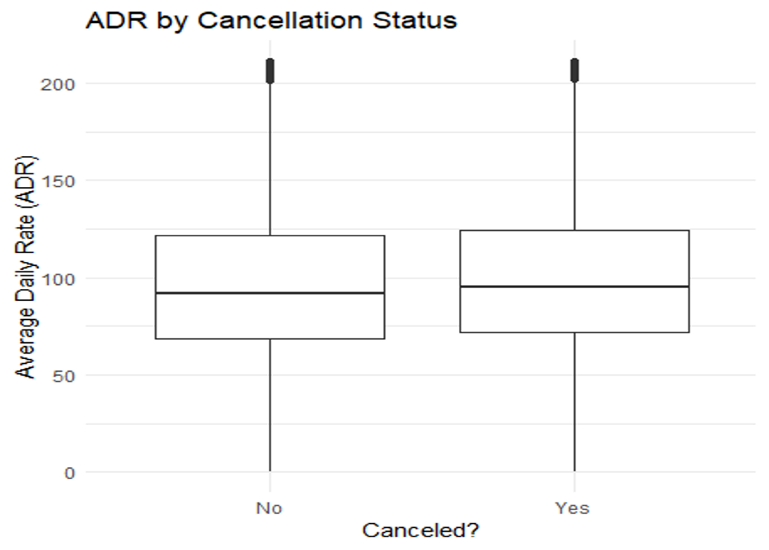

3.3 Total Stay Distribution
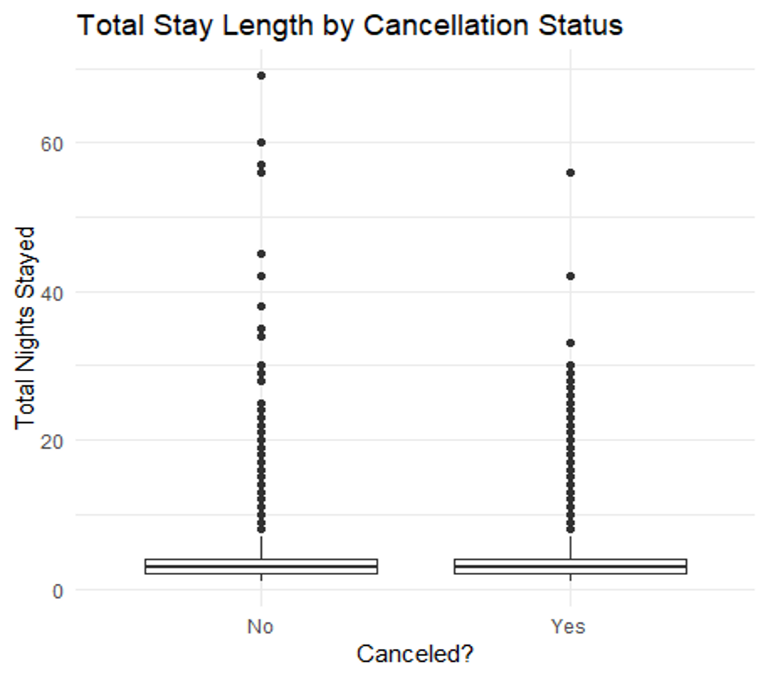

- Mean total stay:
  - Canceled: 3.45 nights
  - Not Canceled: 3.42 nights
  - Total stay duration is almost identical for canceled vs. non-canceled bookings
  - The distributions overlap almost perfectly, indicating no meaningful relationship between stay length and cancellation behavior.
  - Interpretation
  - Guests do not appear to cancel more or less based on how long they intended to stay.
  - This suggests that stay length reflects trip type, not commitment level.
- Interpretation: Stay length is not a significant predictor of cancellations; it reflects trip type rather than commitment

3.4 Customer Type vs Cancellation
- Cancellation rates:
  - Transient: ~41%
  - Contract: ~26%
  - Group: ~7%
- Interpretation: Transient guests are the most volatile; group bookings show the lowest cancellation risk.
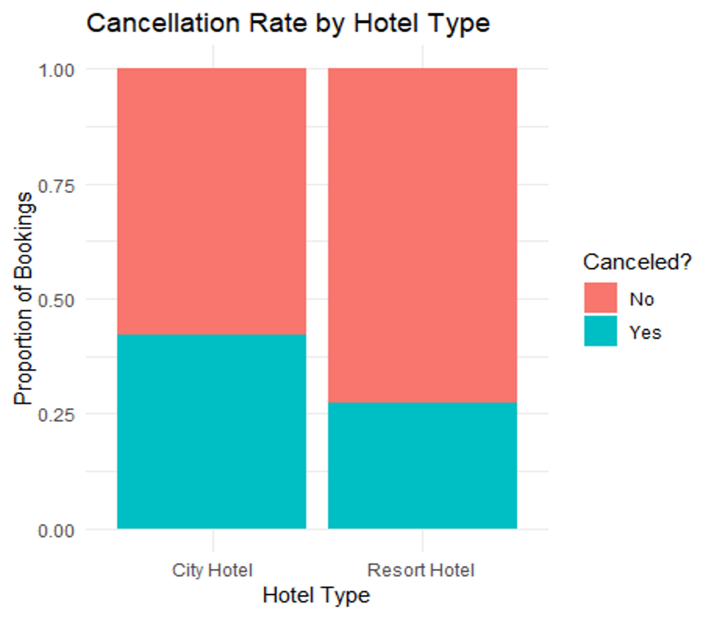

3.5 Deposit Type vs Cancellation
- Cancellation rates:
  - No Deposit: ~28%
  - Refundable: ~21%
  - Non Refund: ~99%
- Chi-Square Test: χ² = 27,335, p < 2.2e-16 → extremely strong association
- Interpretation: Deposit policies strongly influence guest behavior; Non Refund category shows unusual skew, likely due to data reporting rules.

3.6 Hotel Type vs Cancellation
- Cancellation rates:
  - City Hotels: ~42%
  - Resort Hotels: ~27%
- Interpretation: City hotels attract short-notice business travelers → higher cancellations.
- Operational Implication: Different overbooking strategies may be needed for city vs. resort properties.

4. Hypothesis Testing
4.1 Difference in Mean ADR by Hotel Type
- Null Hypothesis (H₀): Mean ADR is the same for City and Resort hotels
- Descriptive Statistics:
  - City Hotels: Mean ADR ≈ 105.41, SD ≈ 33.30
  - Resort Hotels: Mean ADR ≈ 86.43, SD ≈ 46.50
- ANOVA Result: F ≈ 5756, p < 2e-16 → reject H₀
- Interpretation: City Hotels charge ~€19 more on average
- Robustness Check: Levene’s test indicates unequal variances; Welch’s t-test confirms significance

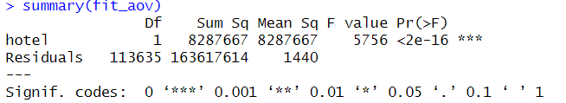

4.2 Association Between Cancellation and Deposit Type
- Null Hypothesis (H₀): Deposit type and cancellation status are independent
- Result: Chi-square statistic ≈ 27,335, p < 2.2e-16 → reject H₀
- Interpretation: Deposit rules significantly impact cancellations; Non Refund deposits behave unusually

5. Predictive Modeling: Logistic Regression
5.1 Model Summary
- Dependent Variable: is_canceled (Yes/No)
- Key Predictors: Lead Time, ADR, Deposit Type, Hotel Type, Customer Type, Total Special Requests
- Model Fit: Null deviance = 105,194; Residual deviance = 71,954; AIC = 72,012
- Multicollinearity: VIF < 3 for all variables

Model Logic:
  - Early-bookers and high-price bookings more fragile
  - Loyal guests & engaged guests rarely cancel
  - Non-Refund coded bookings behave uniquely
  - Transient guests most volatile segment
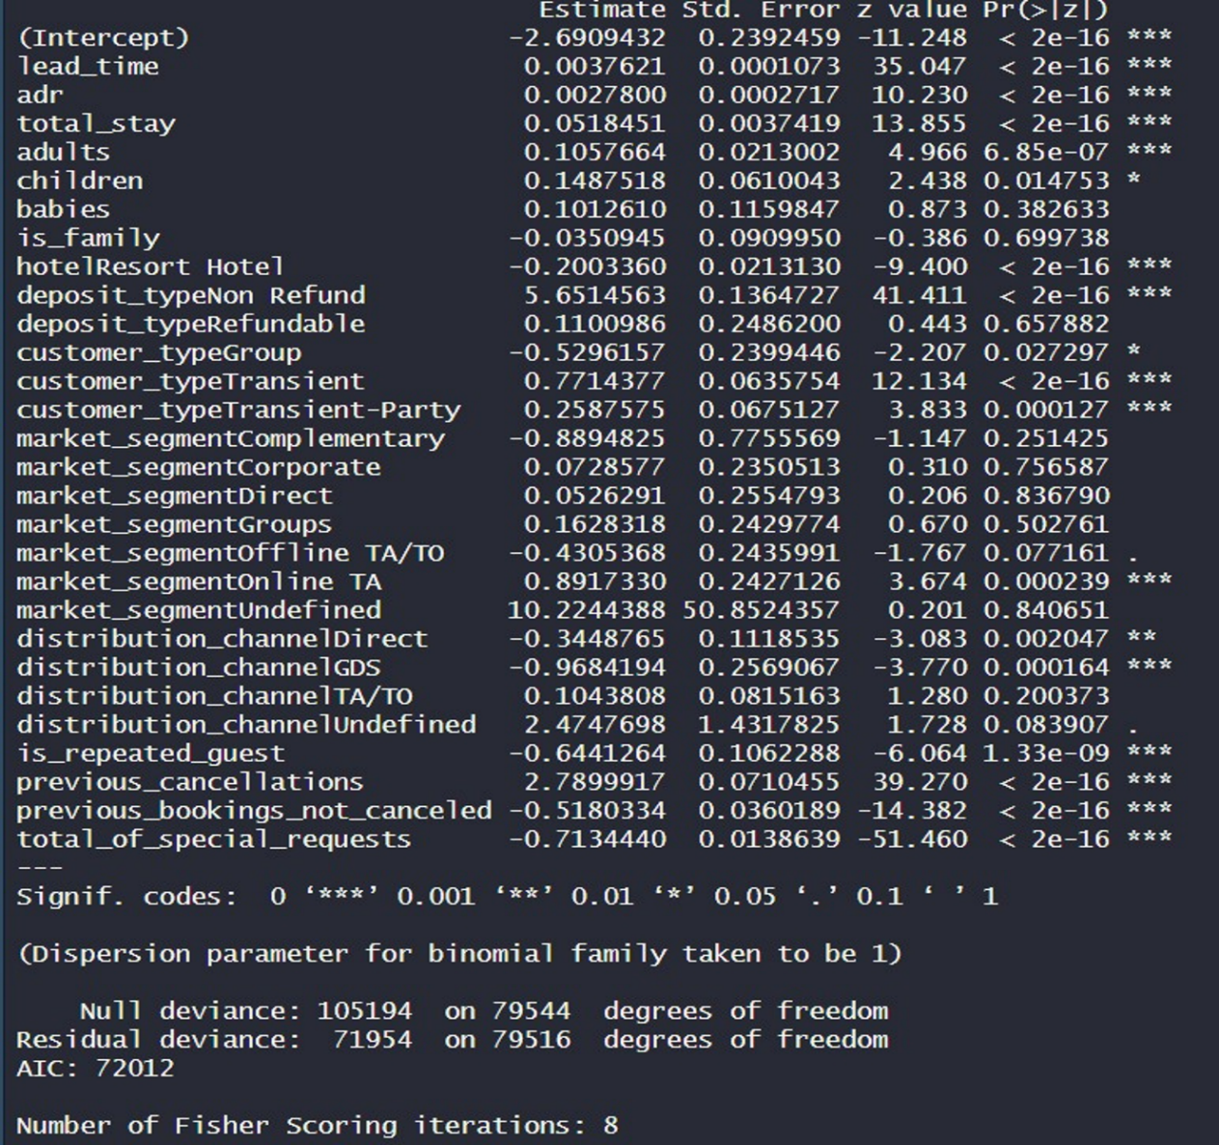
5.2 Key Predictors and Interpretation (Odds Ratios)
Predictor | Odds Ratio | Interpretation
deposit_typeNon Refund | 285 | Dominant driver; extremely high risk of cancellation
total_of_special_requests | 0.49 | Protective; each request halves odds of cancellation
hotelResort | 0.82 | Protective; 18% lower odds than City Hotels
lead_time | 1.004 | Risk; longer lead time slightly increases odds
customer_typeTransient | 2.16 | Risk; transient guests have higher cancellation likelihood

6. Model Performance and Evaluation
6.1 ROC and AUC
- Training AUC: 0.831
- Test AUC: 0.834
- Interpretation: Strong model discrimination; robust generalization
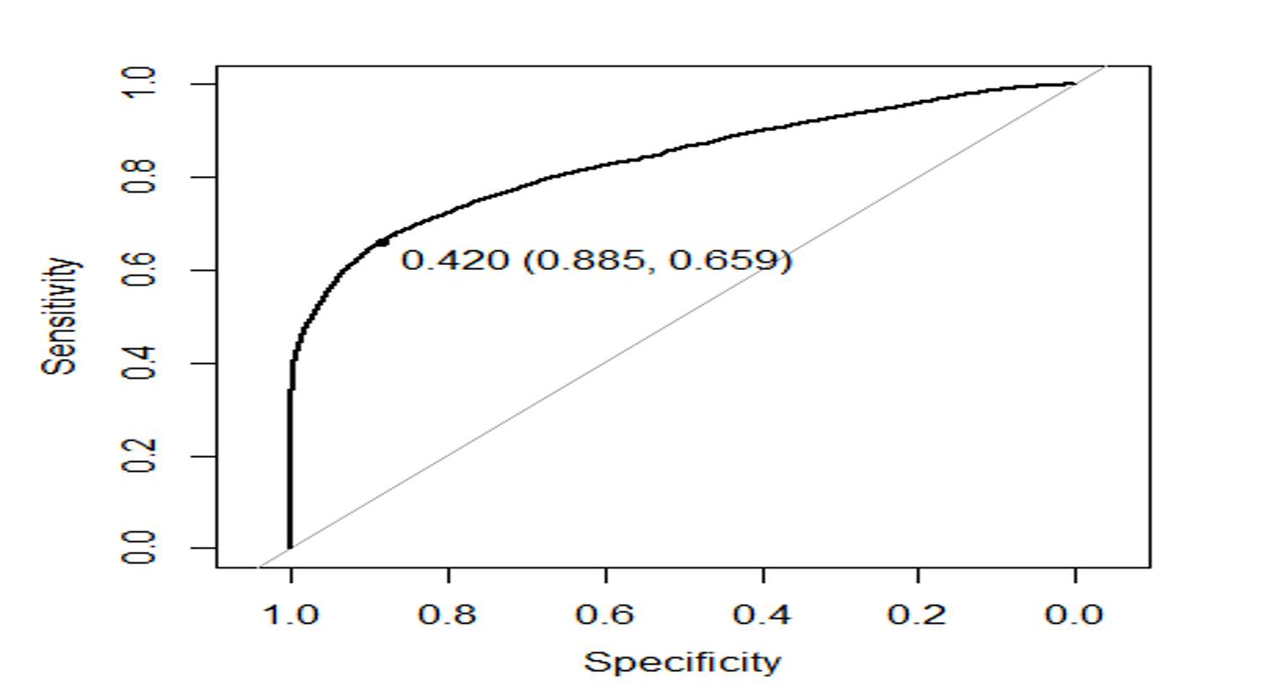
6.2 Classification Metrics (Cutoff = 0.5)
Metric | Test Set Result | Interpretation
Accuracy | ~80% | Overall correct classification
Precision | ~87% | When predicting cancellation, correct 87% of time
Sensitivity (Recall) | ~56% | Proportion of actual cancellations identified
Specificity | ~95% | Proportion of actual non-cancellations correctly identified
Balanced Accuracy | ~0.75–0.76 | Unbiased performance metric

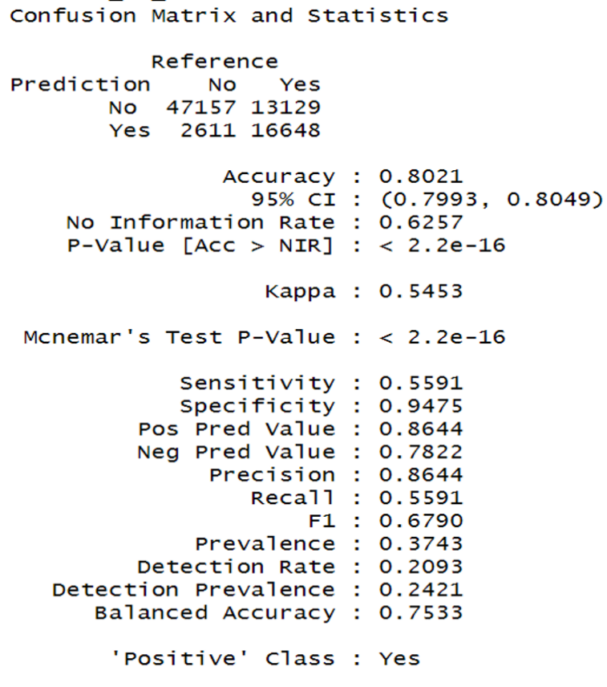

Model Insight: Conservative classifier prioritizes precision and specificity, minimizing false alarms.

7. Key Business Insights
Finding | Implication
City Hotels have higher ADR and higher cancellation risk (~42%) | City Hotels serve more business and short-notice travelers; higher pricing requires tighter risk management and dynamic pricing adjustments.
Customer Engagement (Special Requests) | Bookings with more special requests are significantly less likely to cancel (Odds Ratio ~0.49). Engagement signals commitment—hotels can proactively reach out to these guests for upselling or loyalty programs.
Lead Time is the strongest continuous predictor | Bookings made >100 days in advance have the highest cancellation probability. Early confirmation reminders or deposit incentives could reduce cancellations.
Transient guests and online travel agency (OTA) bookings | These segments show 2–3x higher cancellation odds compared to group or contract bookings. Targeted deposit rules or prepayment can mitigate risk.
Non Refund deposits show extreme skew (~99% cancellation) | Indicates a potential data artifact or business rule; immediate data audit is necessary to correct reporting and prevent model bias.

Additional Operational Insights
- Overbooking strategies should differ by hotel type: higher buffer for City Hotels, moderate for Resorts.
- ADR variability is higher in City Hotels, reflecting business traveler behavior and flexible pricing opportunities.
- Early-bird bookings with refundable deposits represent the highest risk class—these should be actively monitored.
- Special requests and prior booking history can be used to create a risk-scoring system for proactive management.

8. Recommendations
- High-Risk Booking Management: Flag bookings with long lead times or prior cancellations; use reminders or incentives to convert to non-refundable deposits.
- Hotel Type Strategy: Maintain higher ADR at City Hotels, but implement stricter deposits or shorter free cancellation windows to reduce risk.
- Customer Engagement: Encourage early special requests and reward repeat guests through loyalty programs to lower cancellation likelihood.
- Deposit Policy Optimization: Introduce partial or tiered deposits for early bookings to discourage speculative reservations.
- Target High-Risk Segments: Focus on transient travelers and OTA bookings with prepayment or personalized communication.
- Operational Monitoring: Use dashboards to track lead time, deposit type, ADR, customer type, and engagement metrics for proactive interventions.
- Data Integrity: Audit Non Refund deposit data to ensure model accuracy and reliable decision-making.

9. Conclusion
The analysis of over 113,000 hotel bookings demonstrates that cancellation behavior is strongly influenced by deposit type, lead time, hotel category, customer type, and engagement metrics.
Key Takeaways:
- Deposit Type is the most powerful categorical predictor; Non Refund data needs immediate review.
- Lead Time drives early cancellation risk—long-horizon bookings (>100 days) are most vulnerable.
- Hotel Type differentiates risk profiles: City Hotels have higher cancellation rates and price variability; Resort Hotels show more stability.
- Customer Segments: Transient and OTA guests are high-risk; repeat and engaged guests are protective.
- Price Influence: Higher ADR bookings show slightly increased cancellation propensity; pricing strategies should balance revenue and risk.
- Engagement Signals: Special requests and prior booking history are strong protective factors; operational focus on engagement can improve retention.
Operational Recommendations:
- Implement risk-based overbooking strategies according to hotel type and booking profile.
- Optimize deposit policies with partial/tiered deposits for early bookings.
- Use engagement-driven interventions (special requests, reminders, loyalty perks) to reduce cancellations.
- Establish a real-time monitoring dashboard for predictive cancellation risk, enabling proactive operational decisions.
Strategic Impact:
- The Logistic Regression model (AUC ≈ 0.83) is robust, generalizes well to unseen bookings, and allows hotels to forecast cancellations with high confidence.
- Effective implementation of these strategies can enhance revenue protection, optimize operational efficiency, and reduce uncertainty in room inventory management.
- Immediate data audit for Non Refund deposits is critical for maintaining predictive accuracy and operational reliability.

